Gilgit:

Kachura Lake

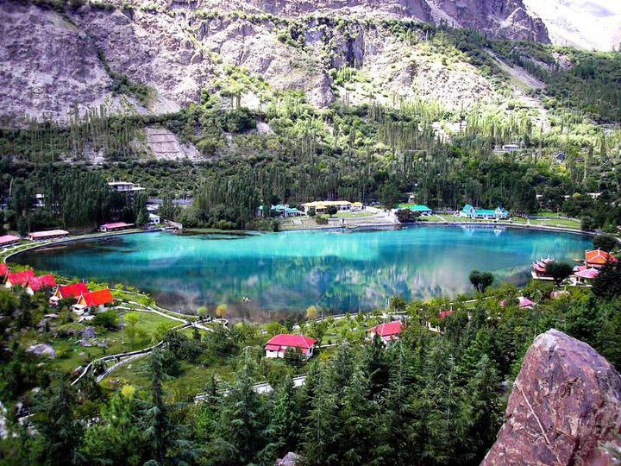

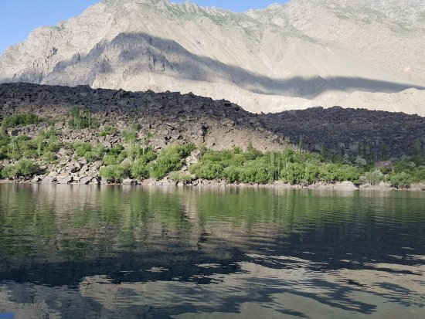

The **Kachura Lakes** are two lakes in the Skardu District of Gilgit-Baltistan, northern Pakistan. The lakes, at 2,500 metres (8,200ft) in elevation, are **Upper Kachura Lake** and **Lower Kachura Lake**. The latter is also known as Shangrila Lake and is within a tourist resort named Shangrila Resort outside the town of Skardu. The lakes are in the Karakoram mountain range of the western Himalayas, the greater Kashmir region, and in the Indus River basin.

Altit Fort

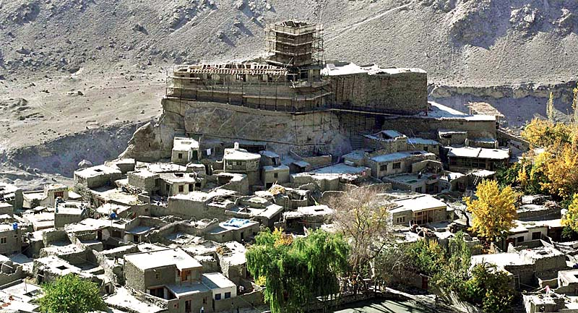

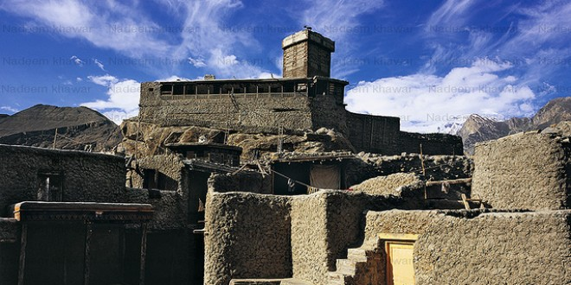

**Altit Fort** is an ancient fort at Altit town in the Hunza valley in Gilgit Baltistan, Pakistan. It was originally home to the hereditary rulers of the Hunza state who carried the title Mir, although they moved to the somewhat younger Baltit fort nearby three centuries later. Altit Fort and in particular the Shikari tower is around 1100 years old, which makes it the oldest monument in the Gilgit–Baltistan. The word Altit means *this side down* and the area around the fort is inhabited by Burusho people. The people of Altit are said to belong to the white Huns, although not much research has gone into the matter. There are several theories about their origin but local indigenous origin holds much value among the people.  It is also said that the present language Bruchiski was brought here by the white Huns in 47 A.D but there is no link between burushaski and any other language of today.

Baltit Fort

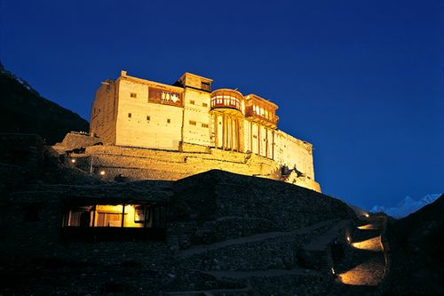

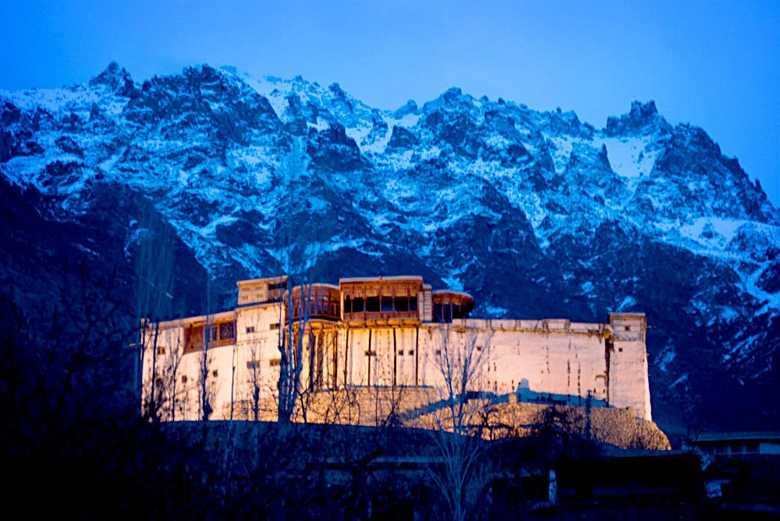

**Baltit Fort** is a fort in the Hunza valley, near the town of Karimabad, in the Gilgit-Baltistan region of northern Pakistan. Founded in the 8th CE, it has been on the UNESCO World Heritage Tentative list since 2004. In the past, the survival of the feudal regime of Hunza was ensured by the impressive fort, which overlooks Karimabad. The foundations of the fort date back to 700 years ago, with rebuilds and alterations over the centuries. In the 16th century the local prince married a princess from Baltistan who brought master Balti craftsmen to renovate the building as part of her dowry. The Mirs of Hunza abandoned the fort in 1945, and moved to a new palace down the hill. The fort started to decay which caused concern that it might possibly fall into ruin.

Hunza Valley

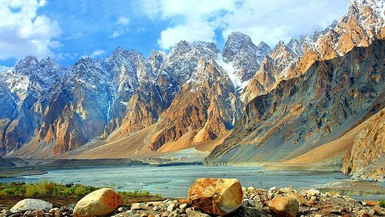

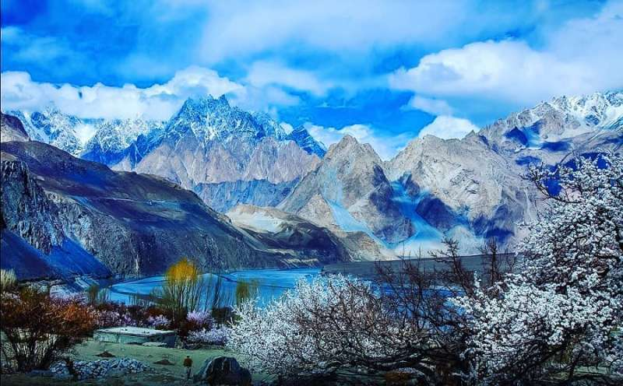

**Hunza** is a mountainous valley in the Gilgit-Baltistan region of Pakistan. Hunza is situated in the extreme northern part of Pakistan, bordering with the Wakhan Corridor of Afghanistan and the Xinjiang region of China. Hunza was formerly a princely state bordering Xinjiang (autonomous region of China) to the northeast and Pamir to the northwest, which survived until 1974, when it was finally dissolved by Zulfikar Ali Bhutto. The state bordered the Gilgit Agency to the south and the former princely state of Nagar to the east. The state capital was the town of Baltit (also known as Karimabad); another old settlement is Ganish Village which means "ancient gold" village.

Attabad Lake

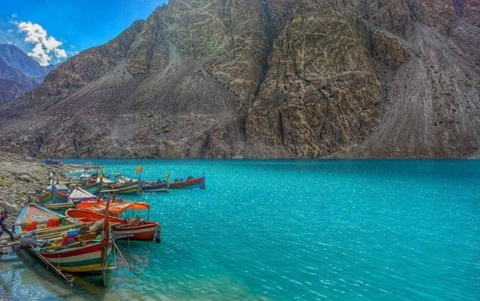

**Attabad Lake** is a lake in Gojal Valley, Hunza, Gilgit Baltistan, an administrative region of Pakistan. The lake was created in January 2010 as a result of the Attabad Disaster. Attabad Lake has become one of the biggest tourist attractions in Gilgit-Baltistan offering activities like boating, jet skiing, fishing and other recreational activities. The lake was formed due to a massive landslide at Attabad Village in Hunza Valley in Gilgit-Baltistan, 14 kilometres (9 mi) upstream (east) of Karimabad that occurred on 4 January 2010. The landslide killed twenty people and blocked the flow of the Hunza River for five months. The lake flooding has displaced 6,000 people from upstream villages, stranded (from land transportation routes) a further 25,000, and inundated over 19 kilometres (12 mi) of the Karakoram Highway .The lake reached 21 kilometres (13 mi) long and over 100 metres (330 ft) in depth by the first week of June 2010 when it began flowing over the landslide dam, completely submerging lower Shishkat and partly flooding Gulmit.

Trango Towers

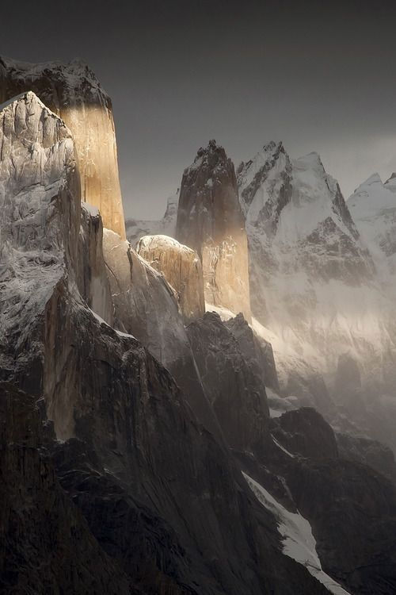

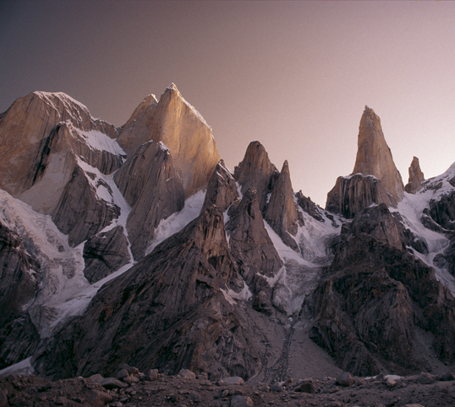

The **Trango Towers** are a family of rock towers situated in Gilgit-Baltistan, in the north of Pakistan. The Towers offer some of the largest cliffs and most challenging rock climbing in the world, and every year a number of expeditions from all corners of the globe visit Karakoram to climb the difficult granite. They are located north of Baltoro Glacier, and are part of the Baltoro Muztagh, a sub-range of the Karakoram range. The highest point in the group is the summit of **Great Trango Tower** at 6,286m (20,623ft), the east face of which features the world's greatest nearly vertical drop.